# Analyzing Seasonal Spending Patterns and Coupon Impact in Online Shopping

Name: Sowmya Banala

Course: INFO 5709

Professor: Hossain Gahangir Student ID: SB1826

# Introduction

This project explores online shopping trends in depth within the context of modern e-commerce, where digital transactions weave a complicated tapestry of consumer behavior and market dynamics. Under the heading "Dynamic Insights: Analyzing Seasonal Spending Patterns and Coupon Impact in Online Shopping," our project aims to expose the intricate details of consumer interactions in the online sales channel. In a time of swift technological advancement and evolving consumer tastes, it is critical for firms looking to improve client interaction and strategy to comprehend the seasonal fluctuations in buying patterns.

# About the Dataset

Our project's dataset comes from the Kaggle website. It's a comprehensive collection of internet customer transactions. It provides a thorough look into consumer behavior and market trends with key variables including transaction dates, product categories, average prices, discount percentages, and coupon data. Transaction IDs provide for the unique identification of each entry, allowing for a detailed analysis of individual purchases. Additionally, customer-centric features such as spending metrics and customer IDs offer valuable information about channel and loyalty preferences. A thorough study is made possible by the addition of temporal and product-specific characteristics, which hold the potential to reveal hidden trends and offer useful insights to businesses navigating the ever-changing world of online commerce.

# The hypotheses studied in the report

An notion that serves as a suggested explanation for a phenomenon that is developed prior to study is called a hypothesis. The report aims to investigate the following theories:

* The first hypothesis would be comparing sales through online shopping and offline shopping.
* The second hypothesis is “Impact of Delivery charges on the sales” such as comparing delivery charges based on the locations”.
* The third hypothesis would be Are their specific products or categories more popular among a particular gender?
* The fourth hypothesis would be “"Analyzing the Influence of Coupon Usage on Customer Transactions”.
* **Hypothesis 1: Comparing sales through online shopping and offline shopping.**

From the above picture we can say that sales through online shopping is more than sales through offline shopping. Customers tend to shop through online as they feel comfortable as they can shop at any time and at any place. Only preferred customers tend to do offline shopping as they cant justify the features of the product by just seeing a picture of the product. And some customers may also think that at other place they may get the product with low price. But now a days like when e-commerce have started the sales through online shopping has increased vastly.

# Hypothesis 2: “Impact of Delivery charges on the sales” such as comparing delivery charges based on the locations”.

The above tree map shows that the delivery charges has vast impact in Chicago locations.

For the online shopping the customers are asked to provide delivery fees for the delivery persons. That may impact on sales as customer may not prefer to pay the delivery fees for the product. And in some locations the delivery fees is less compared to Chicago.

**Hypothesis 3: Are there specific products or categories more popular among a particular gender?**

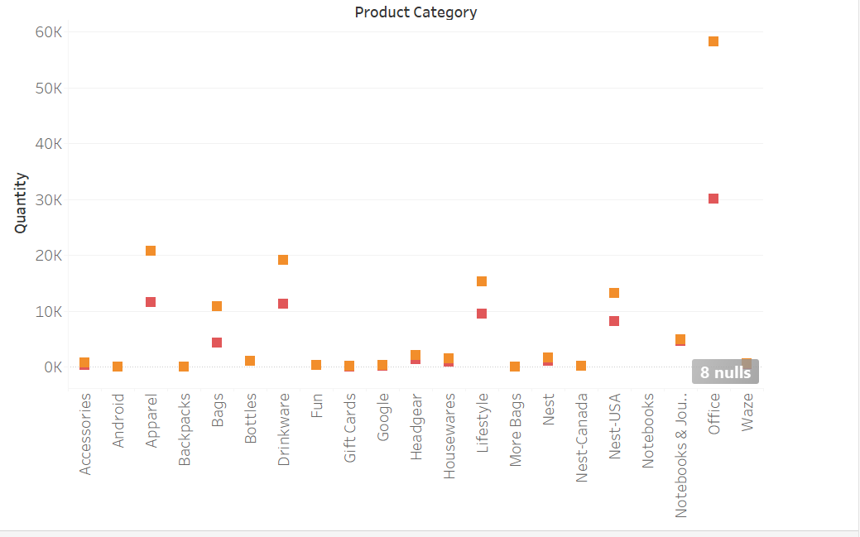

The above picture shows that specification of products vary from the gender. As you can see the graph there a smaller number of males concentrating on shopping that females. For office products the males shopping high compared to other products but in that office products females shopping is too high compared to other products. And among shopping each products females are high in position that males.

**Hypothesis 4: Analyzing the Influence of Coupon Usage on Customer Transactions.**

The above picture shows the bubble chart of impact of coupon code on the products. As we can there are more customers have clicked the coupon but didn’t used and after that some customers have used the coupon in which they will get the product for the less price than the usual prices and then there are some customers in which they didn’t used the coupon so they will get the product with same price. So this might some impact on the product or sales because of coupon.

**Conclusion**

In summary, the heterogeneous dataset provides a rich environment for investigating several aspects of consumer behavior in the context of online buying. The analysis of coupon efficacy uncovers the complex relationship between customer preferences, transaction results, and coupon usage. Knowing the differences in shopping behavior depending on gender provides important information for tailored marketing efforts by illuminating subtle differences in product affinity, spending patterns, and payment preferences.

All together, these study questions offer a thorough examination of the subtleties present in the dataset, laying the groundwork for data-driven decision-making in the dynamic field of e-commerce. The results of these investigations not only deepen our understanding of consumer behavior, but they also provide useful information for companies looking to improve customer happiness, maximize marketing budgets, and hone overall operating plans.